Hardware Summary

AC Input: Design has been reviewed thoroughly. I do not find any connection of 220/110V as state in document the device will be able to power up from AC Voltages as well (US and Europe).

Power Calculation: I have reviewed given battery links in client shared document. The current rating of battery is 2200mAh which seems less as compare to modules, motors, internal circuitry etc.
The Regulator being used are current rating 3A but battery juice is less. For example, the stepper motor has rated current of 1.7A approx. also LCD consuming 500mA as per data sheet. Also there are other parts like Servo, Wi-Fi module etc.
Also need to know how many LED are being used. (Connector J7).

IC7 Enable Issue: Didn’t understand why Pin 05 of IC7 having NET LABEL IO13 is connected with Controller. Is this given to control LCD, RGB or Servo Power?

Servo Voltage Level: Servo Motor and RGB LED WS1282B are both working on 5V. In WS2812B the logic converter circuit is already given but for servo I didn’t see any logic conversion. (IO27 and IO26)

Weight Senor: 500gm load sensor is being used, I just need to confirm what is load of Cartridge that we are going to monitor?

Programming header: Please mention which programmer/debugger you are using. As per my recommendation CP2102, currently best in market.

There is an error in PCB, Net Antenna on IO14. Please check image below.

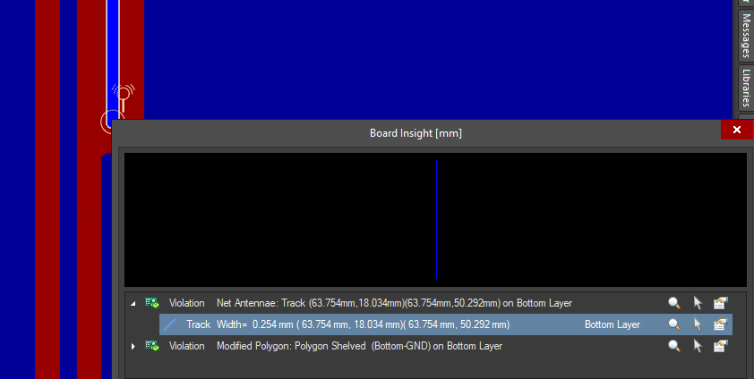

There is a problem with the Polygon Pour (Top and Bottom layer). This will create trouble in manufacturing and production files need to be create again.



In BOM the mating parts should be added. External Modules like RFID also need to be add, servo and stepper motor too.
It is better to print connection or power symbol on Overlay Layer/Silkscreen. It will help user to understand the connection and create ease while testing.

Overall hardware seems complete and good for prototype purpose. For testing purpose all harnessing must be provided and modules will be arranged.

Firmware Summary

1. The firmware is composed of multiple sections. Each section is handling a separate peripheral. The firmware is written taking inspiration from already built libraries and functions.

2. Since it is a replica of the professional libraries with some modification, it is hard to judge whether the developer was really professional or not. The functionality can also be only confirmed when doing actual hardware test.

3. The main ESPProject.ino file is incomplete. The functionality is not completely written and many of the functions are left blank. It is highly probable that the firmware is not useful. However, individual modules for HX711, LCD etc maybe of use once testing is done.

4. The end decision depends on the client whether he wants to test things separately one by one and then one full final test or he plans to burn the final firmware at the start and see where things are lacking.

